Appeal To Our Community Members, Donors, and Sponsors

Dear Community Members, Donors, and Sponsors,
A Historic Moment for NECC – Let’s Build Our Shared Legacy Together
We stand at a pivotal moment in NECC’s journey. Since acquiring our beautiful 16.83-acre property in Germantown, Maryland in October 2021, we have embarked on an extraordinary mission — to build a community center and a Pagoda-style Nepali Temple, a timeless symbol of our community pride and spiritual roots.
This dream is becoming reality, step by step. We are deeply grateful to everyone who has supported us through the Promissory Note Program, helping lay the foundation of NECC’s future. Now, we invite every member of our community to join hands — because every donation, large or small, makes a lasting difference.
This year, NECC has reached historic milestones:
- Site plan officially submitted — a landmark moment in our development process; Public hearing completed successfully with overwhelming community support.
- Barn demolition and new construction approved by the Historic Preservation Commission and awaiting final Montgomery County approval to begin building our new community hall for events and Nepali Pathshala classes.
We’ve also made great strides in strengthening our community:
- Welcomed our new priest from Devghat Dham, Nepal, providing exceptional spiritual services.
- Replaced the temple roof and upgraded to an energy-efficient electric heating system.
- Completed a children’s playground and launched a new website.
- Hosted vibrant celebrations and cultural programs — Shivaratri, Teej, Dashain, Chhath, Janai Purnima, Ganesh Chaturthi, Krishna Janmastami, Community Vigil for Nepal, Kite Festival, Pathshala anniversary, and sports events.
As soon as our site plan is approved, we will begin constructing a Buddha podium, parking lot, updated traffic system, and water-sewer connection — vital steps toward realizing our temple vision.
Now is the time to unite and shape our shared future. Your support today will help us build a lasting home for faith, culture, and community.

Here are specific projects and areas where your support can make a tangible impact:

Barn Renovation:
[ ] $10,000 (Your name will be proudly displayed on the Donor Recognition Vestibule at the barn entrance)
[ ] Custom donation of $ _______

Shiva Podium
[ ] 4x8 sq inch brick $365 X ___ = __________ [ ] 8x8 sq inch brick $500 X ___ = ___________ [ ]
Custom donation of $ _____________ [ ] Shiva Lingas $1000 X ___ = _____________
[ ] Major Donor (Plaque Recognition) - $20,000, Please write your message to be displayed in Plaque (e.g, “In Honor of ….” “Dedicated by ….”)

Here are other ways you can contribute/get involved:
[ ] Dollar a Day ($365)
[ ] $50 General Membership - Family
[ ] $20 or $50 or $100 a month
[ ] $2000 Life membership
[ ] $25 General Membership - Individual
[ ] $5000 Trustee [ ] $15000 Platinum membership [ ] $25,000 Benefactor
[ ] $50000 Patron membership [ ] $100000 Golden Patron [ ] $500,000 Diamond Patron
Pledge Amount: $___________
Donation: $___________
Total Donation: $_____________

Donor’s Name: ______________________________
Spouse’s Name (if applicable, ):__________________
Donor’s Phone Number:_______________________


Donor’s Email:_______________________________

In Memory Of (if applicable): ______________________________
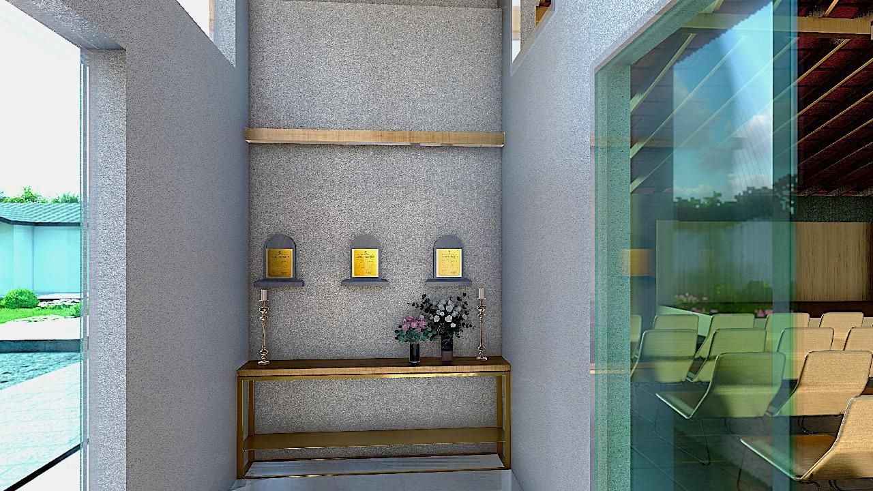

Donor Recognition Vestibule at barn entrance Double your donation. Scan to Zelle

