Naming Opportunity Form
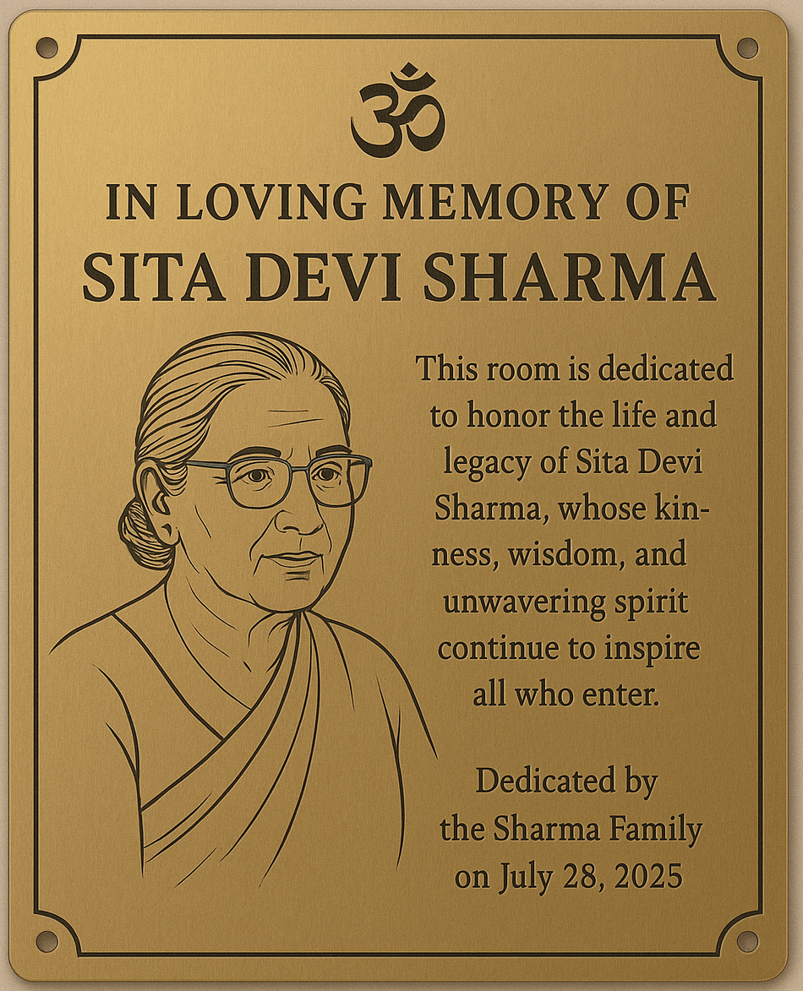
We are at a pivotal stage in NECC’s development, and your contribution through this Naming Opportunity campaign plays a vital role in supporting our site development efforts. By sponsoring one of the rooms listed below, you are not only securing lifetime naming rights to a meaningful space in our Historic Building, but also helping us create a lasting legacy of culture, worship, and togetherness. Each sponsored room will feature donor appreciation displayed inside the space, with a plaque that adheres to NECC’s design standards for consistency and elegance. Plaque dimensions include an 8" x 10" interior plaque reading “Dedicated by [Donor Name]” and a 3" x 10" exterior room naming plate. Whether you choose to dedicate a room in your name, in memory of a loved one, or on behalf of your family, your generosity will be recognized and deeply appreciated. Thank you for helping us shape the future of NECC.
- Main Building First Floor Rooms – $15,000
- Stone Hut – $15,000
- Silo Hut – $15,000
- Main Building Second Floor Rooms – $10,000

Name(s) to be Displayed on Indoor Plaque (required – e.g., “In Honor of…”, “Dedicated by…”): _____________________________________________________________________________________________________

Donor’s Name: _____________________________________________
Spouse’s Name (if applicable, ):________________________________
Donor’s Phone Number:______________________________________
Donor’s Email:____________________________________________

Scan to Zelle: Double your donation:
Preferred Payment Method (required – select one)
- Check
- Zelle (finance@neccusa.org)
- Credit Card (via www.neccusa.org)
- I understand that the full amount must be paid within one week to secure this naming opportunity; otherwise, it may be offered to another interested donor.
Donor’s Signature: _____________________________________________ Date:_____________________________________________

